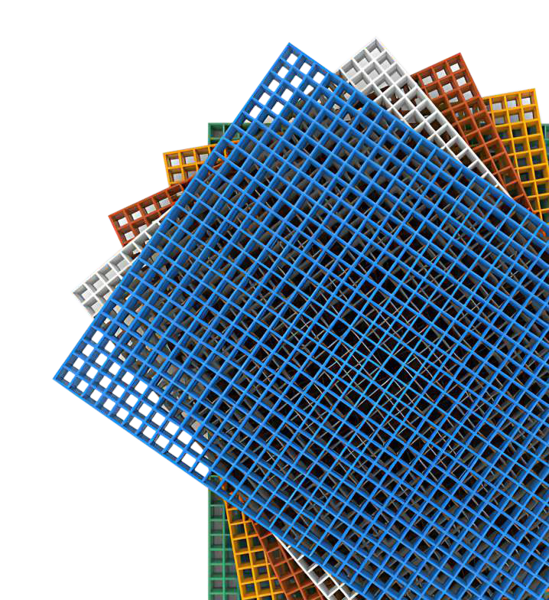

About Us
EstablshedIn1986.EPPhCIS been0twde'fQtt::e forthepcl$t 37+yearswith cledco1ed
eflcltsfor1h9grawthd COf'llXlllllsproductsduttonsl nlndla.

A19ctnologypowell100il9, B'Phas been succsss1'UIInand Cll 18rcishgf1ll9l.Y
eted'lnoloqf1Miloble..,1heWOlld. noclenfswffhcusforrized, erqr e e ed
<XllT'(lOelleprodur;laolU11o1'1$.

SIP provide total 1\lnlleV IO!utlon$ Clld dE!lalled enotieertno seMc:es to °'9rrlcXt Petroc:hsmbl!,Pharmaceu1k::O, Oii&Gas.wata' 8tSa'IHa11on, Power &.£n9!gv. Offshare.. Beclrlcc BUldlng&construction. De<91ice,M=Tran;pollalloi COOll'QTO'Mll. IVlam&,
<l'ldSteel lnc11Stlyv.41h 60+ pl'Oduct-dM:K\soll11ons .

ceitttledv.411'1ISO9001 :2015fOIQMS(QuollfV Manogement system).

7 Manufactung Campuses I 1600+ Workforce Exporting >45 CounfTies I 5000+ Satisfied Customers

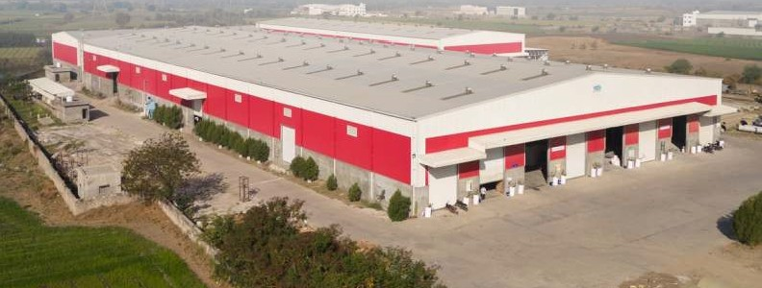

Fl>efVlatl Grating
v.111'1a1egacy otexcellence n1he 11e1c1c:tgrattrQ60IU1klm. 6fclld6 Cl$O leadng bluld v.11h q\.lalrtv; dl.l'Clblllly.andlrno.iallor\ RenC'Mledfor 11$CO!Milment to engheetl precllilon Clld customer sa111focl1on,"CITEn o ctlel'9 raioeor gating products mellci.loulilV C!Cl1!8d to meet 1he sl11rQlll'lt iequrements or vaitous h<:Mlrles. From lnctJsfllalgatt to orc:hlleci\JraldeEigns, each product
reneets hclaQJale'$clecloat1ol 11oeupel1orcral1&110n&hpar.clpertonnonce.With a ocus
en$U8fef nablrty and C\/ltfl'Q«lg& tecmo!ogv.• ·contt008$ to redeftne lndlJ6fry
$blda'd8.e!'IS'Jrtngopll1ia$Ole!Vand11Jnct1onalrtvlnewivapp11co11on.

- -cotl"4)1ele system Of FRP gralilg6 for wakways, plalfom&, *ii$,
bl1dQe$, CJld$ og fowel pocldng 4'.lppodg, effluent trench COYe1aoltler clled u&OQeS of
molded cndpUtrucledfypeO'Qff $hceOdecade.

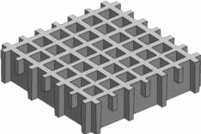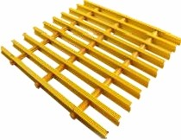

Molded Grating
ManUfaet\.ltng PNICast
Pultruded 6ratlng

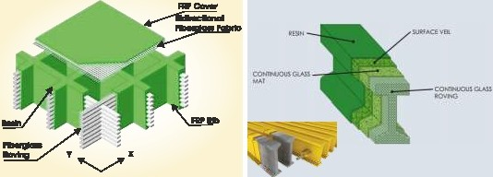

1he panel$ <nmoldedInone.piece,v.tllch P\l11Ucled gaitIQ - flJl!nJcled '1QttigOONl61& he\:>$ d$tltXJ!9 the lood to bothbeamg and of moiegj08Sthan,_.,,11'11$fype ot(101fng1$ cross bars. Continuous fiberglass rovhg created byasel1esalpaallel loadbars1l1at
v.1ndng In a1tematt1g lay&rs Iii fhorough!V are lepf paralel by a SEHlas d cross rods.
wettedwith rem, nthe load IsaPf)ll9d1G These bars are fabricated by pulllng
1lle grattng, Ille weight 1$ 1lan6fened tollberglass roving through a pultruslon
od)Olrlng cross bar$ al\d beartig bars for macl'lne.
EIWll'lloaddsht>u11cn.

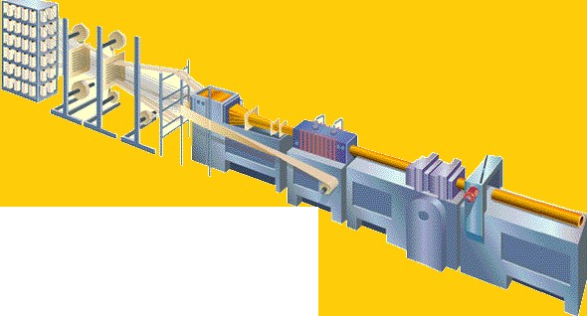

PuHruded SecHon Manufacturing
Proceu for Pultrudec::I Grating

EPP CGmposllas Pvt. Ltd.
Since 1986

hdkltf'Qte"' Grating
A high quality FRP Grating system offertng a wide choice of sizes, material 1YPeS & appllcatlons. For safety crttlcalapplications 1he product has been tested and approvedto standards llstedlater In1hlsdocument.
The range is designedto offer o cost effective,low maintenance ottemative to stainless or galvanizedsteelwhenused InreN buildor refurbishmentprojects.
Avollable In a range of colours and finishes,Fl<P Grating provides all the advantages of llgh1welght,highstrength anddurability;coupledwith acorrosionresistant.maintenancefree, minimum25 yeor lifespan.
The gratings are manufactured from polyester resin by a molding process with a choice of resin1ypestosuitallenvlronmen1s.
They provideworker or generalpublicsafetyand comfort Inavariety of locattons throughout Industrialand publicaccess areas.

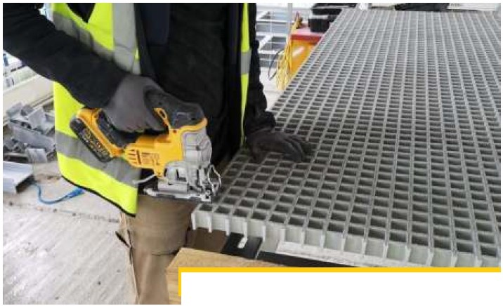
Molded 8raHng Manufacturing Process

General Properties & Design Criteria
1.Chemlcalresistance
Corrosion Is a major problemfor metal or wooden gratings,stair treads and other products In lndustJ1es such as chemical plants,food and beveragefactories,water and wastewater andpower facllltles. FRP grating Is designed to provide safe, long·lasting,economicalsolutions Inenvironments where chemicals and other corrosive elements attack and destroy metal or wood. According to the env1ronmental requirements,a choice of resin type such as Orthophthallc, lsophthalic polyester,Vlnylester and Phenolic are offered In the matrlxmaterlal.

- High strength-to-weightratio
FRPgrating Is manufacturedas a composite of continuousflbreglass strands and high qualHyresin Integrally constructed for strengthand Is only onequarter of theweight of acomparable steel gratingaliowlngfor easy removal,access below floor leveland Installation with no heavy equipment and less manpower. Properly installed,FRP meetsthespecified loadrequirementsfor steel gratings and has greater impact resistance.

- Fireretardant
FRP grating is manufactured to achieve a flame spread rating of 25 or less depending on the resin system used - as tested to American standard ASTM E-84. other types are available for special fire
retardant requirements and can met through material additives which achieve a reaction to fire classification of Bfl - Sl in accordance with EN 13501-1 + Al :2010. Test reports are available on
request.

- Ergonomic
Where employees may experience fatigue after standing on solid concrete or heavy galvanized steel platforms, FRP gratings are the best solutlon to ease the strain on the back. feet and legs of workers, Increasing comfort and productivity. In a raised floor scenario,the natural slight flexlblllty of the material Is morecomfortable tostandonfor longperiods.

- Sllp-reslstant
FRP Molded gratingnaturally has a concave top surfacefor slip resistance after it isextracted from the mould. For additionaldurability, EPP grating incorporates as standard,a high quality aluminium oxide grit surface which is bonded to the top of the completed grating under factory conditions providing superior skid proof andwear resistance. Diamondpatterned covertop or gritted cover tops are also available.

- Long Product Life Expectancy
A lifespan of 25 years Is guaranteed for EPP gratings, when Installed under correctly specmad conditions. Fibreglass products are knownto be In use considerablybeyond this time with only cosmetic degradation to theproduct.

- Lowmaintenance
Install and forget. FRP grating Is easy to clean,open mesh versions permit debris to fall through the grating panel and prevent any hazardous buildup on walklng surfaces. Gratings require no re-painting and are excellent not only for their Inherent chemicalresistance but also a colour-fast appearance and ultrav1olet resistancecharacteristics.

8. Safety
NON-CONDUCTIVE properties make gratings Ideally suited In electrically hazardous locatlons acting as an Insulator. NON- MAGNETIC properties allow gratings to be used In sensitive lnstallatlons where the Inherent magnetic properties of metalgratingwould provedangerous.

9. CommercialAdvantages
While the cost of FRP grating is marginally greater than steel,installation costs are around 20-40% less than that of steel and maintenance cost is near zero. Steel gratings may require regular maintenance and the accumulated costofthis is high.

Lifecyclecosts for FRPgrating have beenshown to besignificantly lowerthanthat of steel leavingasidethe otheradvantages itoffers.

Resin Selection
EPP manufactures grattng with a varle1y of resin, each with unique performance characteristics. Resin selection is paramount in determining the corrosion resistance of thefinished product.

Our gratings are manufactured with fire-retardant properties that can comply to FR ratings of thesystems likeASTM E84-Class l,BS-476part-5,6,7-Class landUL 94-VO as per clients' requirements. The resin system comprises of additives that gives a UV stabilized product so that the properties of the products do not degrade considerably over time. Also,the aesthetic valueof the product is retained. The pigment inthe resin system used complies to the TCLP Declaration in the USA. As per the clients' requirement, if anti-static properties are required, the resin system can be prepared accordlngly to fulfill the requirement

Typlcal Materlal Properties  Densl1y kg/m3 (Specific Gravl1y) |  | Value  1250
Hardness (Barcol) |  | 38
Tensile Strength Mpa |  | 69.01
Tensile Modulus Gpa |  | 3.l
Flexural Modulus Gpa |  | 3.288
Flexural strength Mpa |  | 107.3
Impact strength KJ/m2 |  | 10
Flexural Modulus Gpa |  | 3.13
Elongatlon at break %  Heat Distortion Temperature °C |  | 5.89  79.l

Fibreglass Properties

Typical Material Properties  Densl1y kg/mJ (Specific Gravl1y) | value  2500
Water Absorption % | 0.2
Compressive Strength N/Tex | 0.42
Line Densi1y Tex | 2400
Line Densl1yvarlablltty coefficient % | 1.71
Diameter m | 24

Strict control of raw materials ensureanexcellent andconsistent qualityto the product. All raw materials aresourcedfromcarefully selected suppliers

Chemical Resistance capability

ChemIcal | Max. Oper. Temperature
 | % Cone. | Vlnylester lsoph1hallc Orlhophthallc
Hydrochloc acid | 30 | 82 |  | 65 | N/R
Nitric acid | 35 | 38 |  | N/R | N/R
Sulphuric acid | 25 | 82 |  | 65 | N/R
Hydrofluoric acid | 10 | 24 |  | N/R | N/R
Lactic acid | 100 | 82 |  | 65 | 60
Hypochlorous acid | SAL | 60 |  | N/R | N/R
Citric Acid | ALL | 49 |  | N/R | N/R
Potassium hydroxide | 10 | 49 |  | N/R | N/R
Sodium hydroxide | 10 | 82 |  | N/R | N/R
Calcium hydroxide | 25 | 82 |  | N/R | N/R
Calcium hypochloride | 25 | 82 |  | 65 | N/R
Ferric chloride | 100 | 82 |  | 65 | 60
Aluminium chloride | ALL | 82 |  | 65 | 60
Mercuric chloride | 100 | 82 |  | 65 | 60
Silver nitrate | 100 | 82 |  | 65 | 60
Sodium salt | ALL | 24 |  | N/R | N/R
Zinc chloride | ALL | 24 |  | 24 | N/R
Acetone | 100 | 1 24 |  | N/R | N/R
Chloroform | 100 | N/R |  | N/R | N/R
Fuel | ALL | 38 |  | 38 | 38
Nantokite | ALL | 82 |  | 65 | N/R
Phenols | 10 | 24 |  | N/R | 38
Ozone | ALL | 38 |  | 38 | N/R
Bleaching llquld | ALL | 82 |  | N/R | N/R
Ammonium hydroxide | 30 | 24 |  | N/R | N/R
Ammonium salt | ALL | 24 |  | N/R | N/R
Black sewage | ALL | 82 |  | N/R | N/R
Cupric oxide | ALL | 52 |  | 52 | N/R
Glycol | 100 | 82 |  | 65 | 60
Sulfur dioxide | SAT | 82 |  | 65 | N/R
Sodium phosphate | 50 | 82 |  | N/R | N/R
Water | 100 | 82 |  | 65 | N/R
Alum | ALL | 82 |  | 65 | N/R
Chlorlne water | SAT | 49 |  | N/R | N/R
ALL- CONCENTRATIONS | SAT- SATURATED SOLUTION |  | N/R- NOT RECOMMENDED

lndlofrote™

SIPClnlpllllls M I.Ill.
Snce 1986

Avallatlle Top Surface
-Molded vrai•+ ae CllCllcblB n square 01 rectaroi1ar meih palte.ns wtlh emoot\ <111•Md l1fl1llCi Mac& c:lld <XMlledglltt'(j wtth <111•Md grttted picl!e01llilttltll$c:l>eque."ed ploteanc::Ullhlmefdemand.

-Nlrlldlld 9lllffngs ae avcllcJble v.1111 smoo!h and an11-slild 1op
«lfocecncustoc1IE!l'demand.

Molded Gt'Cltlng Surface

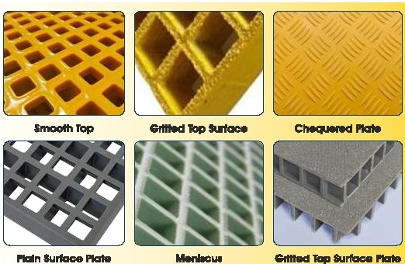

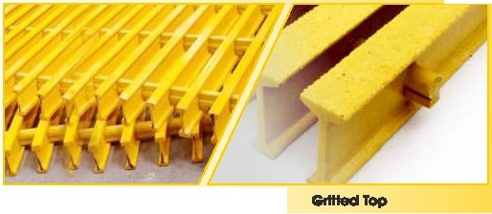SlooolhTop


EPP Composites Pvt. Ltd.
Since 1986

lndlafral"e'" Grating Selection
EPP offers both molded and pultruded gratings. The following table provides assistance inselectingthe bestgratingfor the requiredapplication.

Features  Structure | Molded  Monolithic | Pultruded  Eccentric
Corrosion Resistance | Higher | Higher
Bi-directional strength | Excellent | Non-Recommended
Unidirectional Strength  Impact Resistance | Very Good  Excellent | Excellent  Average
Fire Retardant  UV Protection | Good  Good | Good  Good
Anti-skid Surface | Possible | Possible
Weight Saving v/s Metal | Excellent | Excellent
Open Area (Air-flow.Light Penetration) | Excellent | Good
Safety | Excellent | Excellent

Standard Colors
Gratings can be manufactured to any RAL colour specified. The Molded-in colour is achieved by a consistent mixing of pigment and resin. The fresh colours can enhance theworkingenvironment withgreat effect.
DOD

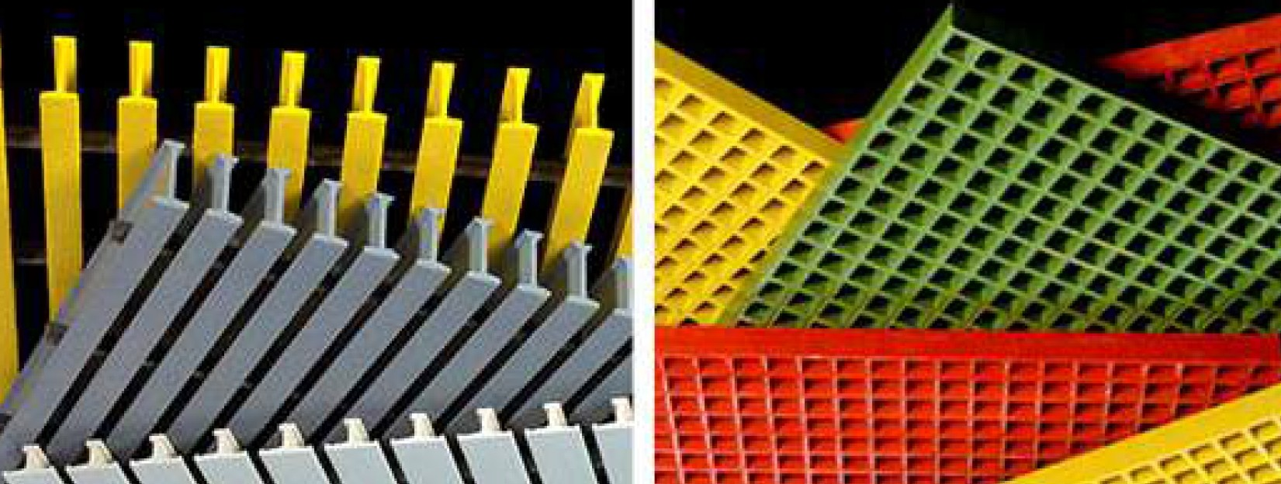


EPP Composites Pvt. Ltd.
Since 1986

Operating Temperature Range
The material exhibits awide operatingtemperature range typically Minimum -50"C to Maximum +l00°c

Fire Resistance
Manufacturedandtestedwith fireresistantproperties in accordancewith American Standard ASTM E-84

Viny1ester.lsophthalic Class 1. 25 or less High Flame Resistant Viny1ester: Class 1• l O
or less Phenolic:Class 1.5

Dimensional Tolerances
ManufacturingTolerances :

Standard Panel Size: ±lmm I Cut Panel Size:±2mm Thickness: +1mm
Mesh Pattern: ±0.5mm

Mechanlcal & Electrlcal Properties Characteristic
Tensile Strength

Tensile Modulus Flexural Strength Flexural Modulus Compressive Strength Compressive Modulus Flame Spread Index Water Absorption Surface ReslstM1y
Axial Dielectric Strength Warp Dielectric Strength Relative Permittivity Dielectric Dissipation Factor Barcol Hardness

Value
411Mpa 24.2Gpa
763Mpa 18.5Gpa
451Mp

23.3Gpa

10

0.279%
l.4xl 0100 9.7kV/mm
l.384kV/mm 3.97
0.028

48

Test Standard
ASTM D-638 ASTM D-638 ASTM D-790 ASTM D-790 ASTM D-695 ASTM D-695 ASTM E-84 ASTM D-570 ASTM D-257 ASTM D-149 ASTM D-149 ASTM D-150 ASTM D-150 ASTM D-2583

lndtatrate

lft N. IJIL
Sb:a 19118

standardklmlable Graffno 11118
hclloilGN'" MoldedGrating Specll'lcatfons

llem COde
Panel .. Melh 111111111 llohm
""'"' ""'"' ""'"' (mml
lllt*I..

Gl-163838 1220<3M0 38x38 16 6.2 6
·GT-263838 1220lc3660 38x38 25 6.2 5
GT-303838 122Qic3660 38x38 3Q 6.3 6
GT-383838 1220ic3660 38xS8 38 6.3 5
Gl-381919 15451<4045 19x19 38 7 6

helclilt.l'IW'Gl-606060 | 1220<4046 | 60l!50 | 60 | 79. | 6
h*lfltC119'G2510025 | 1220ic3660 | 100x25 | 25 | 5.9 | 5
-G3815025 | 122Q<3MO | 150x25 | 38 | 12 | HJ
-GT-384040 | 122Di<4015 | 40x40 | 38 | 6.3 | 5

rdc)jrate"Ntruded Gtal•ig Speclf'lcallont
...
llllll'I COcle eiattng M& Weltht a111110
fmw1a.1mmJ laad C I aitr
hda:i!..W.'GT 2!iP 25mm He1111t 2400c1200 11.SIO'm* 250
hi:tcllrltCll9•GT""361' 38 mm Hel(1rt 2400c1200 15.6 'fli]/rri" 600

. . .

-
GT 60 mm HB111rt 2400ic1200 19.5
·S--.2'imm -.1.
3 .11"m
10100

.I 38.11lYTl
-?ii'- 1
6.0MM

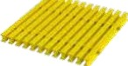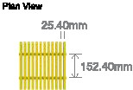15.24mm10.16mm
1W1111nlu¢
2S.4011'f!l

lndlafrate™

EPPeom,111111Pwt. Lid.
Since 1986



FGstentng Cllps •1nstallaHon Methods
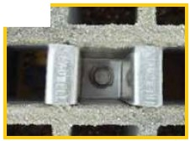lnstalattonAcce 1sortet
-
lh9l'T10Lfd9d FRPIJtlffngprodJcls CJ'&compllmen!edbl/anEOOa'lsMI rangeof
fWnglype$ald lnsfallatlonsyslem&.AU nlO\ided FRPIJ'(Jffngmtalatloncfp4Gls CJ'& tes1ed andplOYel'I to 1\Jrcllon Inthe l'ashast at olfemg you tolalpeaceotmna.
All at the mouoecl FRP(1a1hgnstallallon systems er& suppliedend stocted as 316gracle star"9sssteelwttl\ uper 30411'Cc:f 9stalnlllss <JnCI gailla11sed nelopttoma.datli914lO!l .Tlisfied>llylTl90m thahY9 CO'I provld9 a
Clbl9$0!1.1110nt01v.natew1Chemlc:al$01opplloatlon hOV&.

lhemoulasdFRPgattrgdlprangealilonduaesalargeraofundar31cl9dlpil
ocldtlonaloptlongwhenwhende$01 1rGre&v.1thlheoonlldetal looolflxnQ niethoct5.

Cllp·Tops

:srAlllDAADeM 30 I PlAN TuEIE\IAllON TFAm!llllGOPllONS
I 1.3.4,6
McINIM-ESH M s-,1 ,,30., ·PlAlN·IEulfVl\JION IFA81811tl6 Ol'DONS
6 7
•
lh9oded hoB WA

OU: : I 1r ID CJI I ri 11 I !1, 7
MINIMESH M DI 30 PlAN Elf\llQICJll FASIB\ltl& OPllONS
lh9aded hollK t¥A . LJ .
:!headed hob=;.,.-.,..:J-_1 I T -_--J'l T 2
c ao PlAN ElfVAIKlN FA81811tl6 OPllONS
II
HMoatl&ecDkial ne18:13:616.""' I T l. T 2
L 30 PlAN ElfVl\JION FA81811...SOl'DONS

lh9aded hoB t¥A
:,=: 1 I T T1.3.4.e
D 30 PlAN EIE\IAllON FASIBll...SOPllONS

=slfltlhl9CJdad hole;: N.IA I T IT
E ao PlAN Elf\WION FASIB\ltl& OPllONS
I f 1,3,4,8
lh9oded hoB WA '
W I 30 PlAN TElfllA'llON TFASIBll...SOPllONS
OU: : 1,3,4,G
lh9aded hollK t¥A
HMoall&9Dctlaml'I1W1>9&le:3l:816n1m11'11 I T T 5,7
S 30 PlAN EIS\lllQICJll FAS1911...SOPllONS

llYeoded WA '.....;.
hol&:
o ao PlAN ElfVAllON FASIB\ltl& OPllONS
HoleDtcr11e1111:errm  Maledal :316""'  l1woded hoB WA |  |  |  | 10.11

lndiofrate™

B'PConpdlet PiilIJll
Since 1986

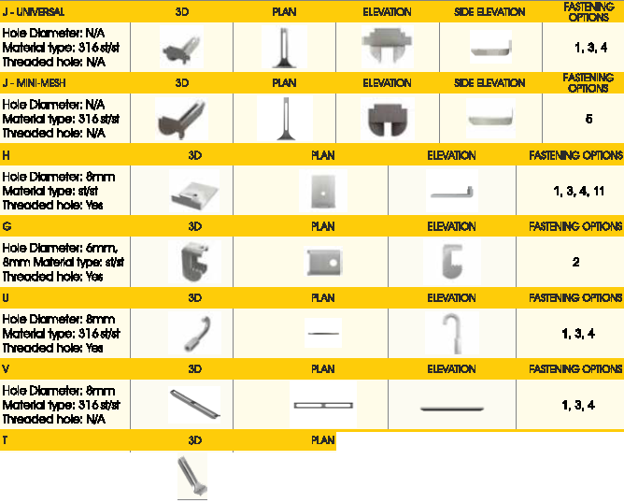Clamp Undenlld9
.......

...... - El£VA1ICIN - FASIBllNGOPllOlllS
Hole Cbnehit. NfA Mal9Ctal 'IW>&:ll16111'1t l1V8Cldecl hol&: f\UA |  |  |  | 1, 3,4, 9
Futanlng Op1lonl
I 2 8 4 6 -
I I I I I

......
-. ....-
._.at...._,, ._......o._i....•_.11_•. ...,..., M8.M.l....,.i:.- ...............".".".,.-°"'
11,... .1•
..._

.,,_"'"--
. .Ucnl-•
""_ -,,___
1.8.e.iO..IM-ll-l*l.flladOS>llllS

-a tf - -·
·-"'....
-....-- ......u

- 0 -- D
im m -

.......
....,...,....,,. ...,..T.,'"".4.,... r
_._..,_,,,_,..._

...._"
-·,·--
-·,·-- -
___.,.,

-,,••""'...M-_lm·.llp, -812>c1Dm11'ml-_,·.,..
·=net...a1•
.,,.
,
"-"·_.,,...,
1-111·a1•••1•
,M. xtKtanr•n••c•ot•u-.a

,, Q141JOmn _.. fOOI ,.•.,,.. Mllad lllt 81•d0mn ea.-...
I
-- -1·

lndlofrote™

Acc111 m.t
M-Clp{SaddleCUp):
M.OIPll 019 Uil9d 10 secure maldad OI pultn.!ded grallng PQ'lelS IO $"'3POlf using two ogramg bm for a
secureflt

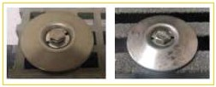

l Clp(End Pal'llllClp):
L-Ops ore used to faB19n molded a
pullrud9d g to suppO!f b<I' for
mooeratelocxis

HIP Cll'nplllltDM I.ill.
Snee 1986

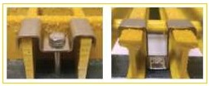

W.Clpl'WmfNHClp)c
W-O!ps a& macf9 d specltkxllv for pkJte OI gramg With plat9 Oil 1op. 1he leng1h of 11'19 bat should COf181PQlld
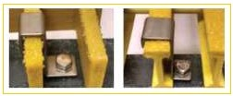¥lilh lhehell;lltof lhepanel.

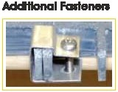(&IdPanelClp)c
CCl!ps ae used to !00 two ends of molcl9d gramgs togell!Gi.

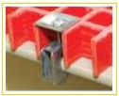Clpll:
G-Oipsored9:!fgl9CI toattachgra1\'lg!10onvst11.1c1urc1
merriletamallern1hlckne$$, With nodll reqlftd.

J.9o!tt:
•
.
I II
r_;·
J-Bclll$aeusedtoaecll8gat1nQ$10atxr.

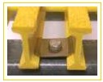T-c!lpt;
T.O!psare used tofastenplJ!Ncled gramgsloa
frcm9.

lndlofrote™

lntfallatlon Procedure

ACCEPrAlllE

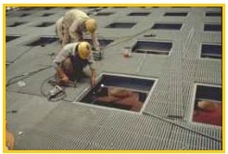
Trained Gl'a1tlglr.stalc11on
Teem Ofll.Y

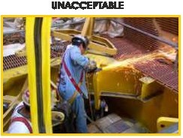Non-Trained GrattngInstaller

HIP Cll'nplllltDM I.ill.
Snee 1986

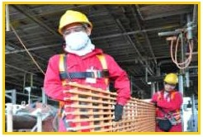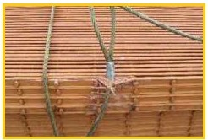

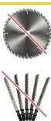Hcrd9 (1CtTlg os not 1odcrnage It.
Wealong SEIEl\eS endglO\l'el).

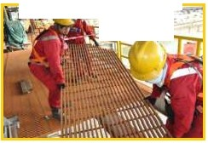
-:. 1-.:J!".....
x -· -
Hand Rt Onlv

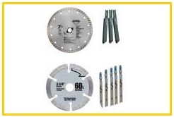
Orcula'sow G111ted or
Dlcrnond (30 gtt SIZel
Avola handing grattng v.f1h CCltllas
that can damage 11.

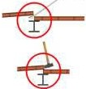

DonotfCNCe graffng tools

lndlofrote™
Installation Pracedure
S.'G08fled Tool Paoc:edure• PelIElltalkMHole C\tts
leng1h (l) 1 ..I

eutout Fane! rr.:xict

HIP Cll'nplllltD M I.ill.
Snee 1986

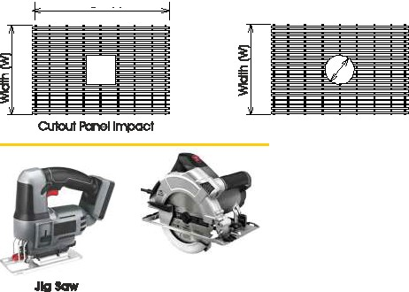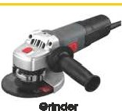

arculcrSGw
Too largefa imal
penelrOllOiIS
Agfnc:ler Q'\O\JlaneYar beused to eutFRPI GRP gralkig.

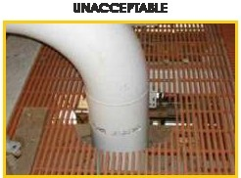
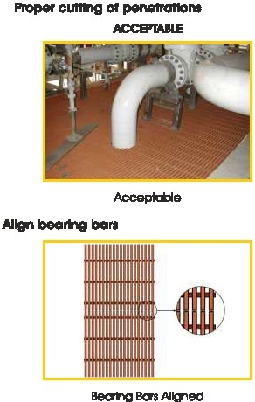AYold CM!r-Cu!!Tlg 11'19 Penetra11on
{Remalllngmaebeanng ba1111han requrad)

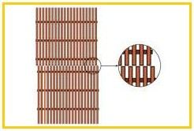
Unac:oeptable

lndlofrote1M

BIPClrn ."--MUii.
Snce 1986

lntfallatlon Procedure
Algn llealtng llcn

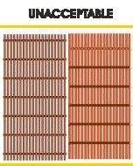
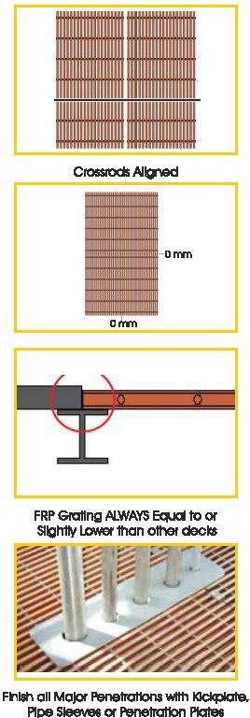NOTAlgned
II.
--

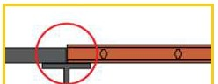

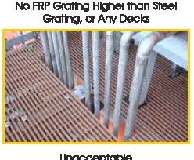

lndlofrote™

lntfallatlon Procedure

HIP Cll'nplllltDM I.ill.
Snee 1986



I I I I
I!I Htfl'lni. I !IHl!ft'TI I I 5. lllltnl!'I I ! i !
± i1+'---,-,,,.,.., ·I I "'a.'""' I

<1118 mm opG!'I span !es USCG/ClcllSreqUIUI 18l1ls fer ff 19 lntegnty gur•igLElllel 3, 2, l.•
>1118l'l'tn open d09$ not complywith USCG /Class 19qU!remants fer ft'e lnte(Jtty grattng lell9I 3,2, I.,.

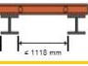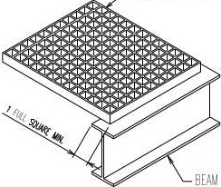>1118mn open $p(l'l does COi t P'f USCG /ClaS$
l'eCIU!e! t 181!IS for 1119 lntegrttv gaftigLevel 0 ONLY.

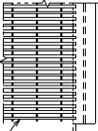
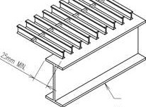PULiRuDEll lllAll _<,_.2.5,m,"m".....U.o-

PULTRUDED GRATING

BEAM
MOLDED GRATING

ODO
,DOD
'§§§
·BBB
1888
000
WllOOI CllAll .IL
< I SOlll'l[ I

lndlai-5rate™
AppllcallOnl

B'PClm,....l'wL 1..111.
Since 19116

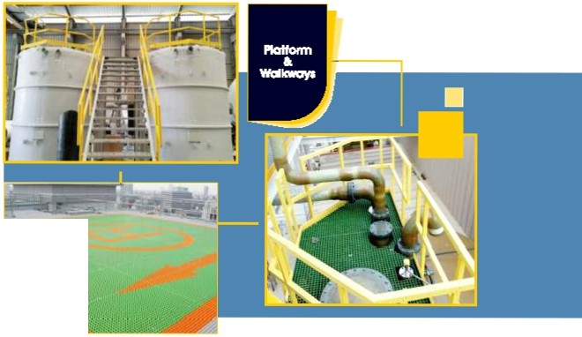
Hellpad
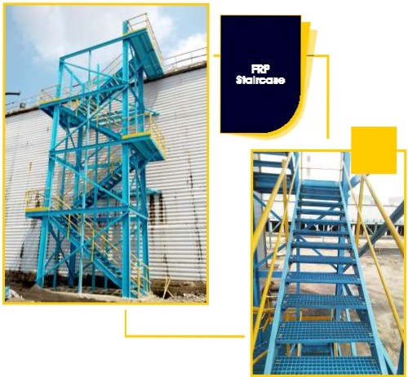
•

lndlofrote1M

HIP Cll'nplllltD M I.ill.
Snee 1986

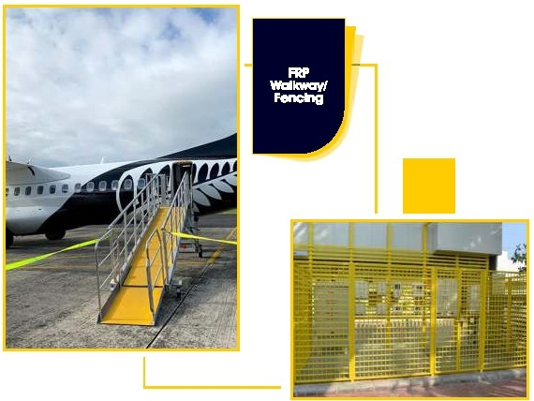
•



lndlafratelM

El'l' Clm,.....- MLM.
Slnce 1986

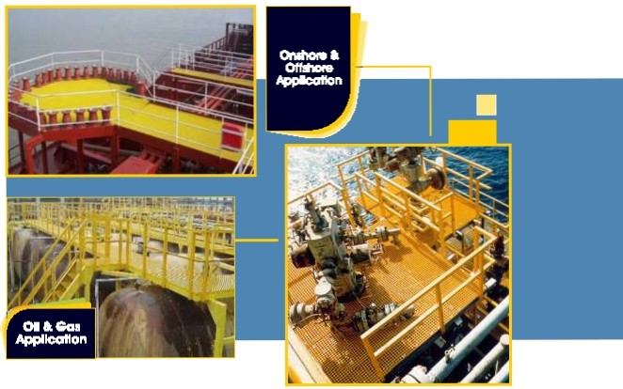
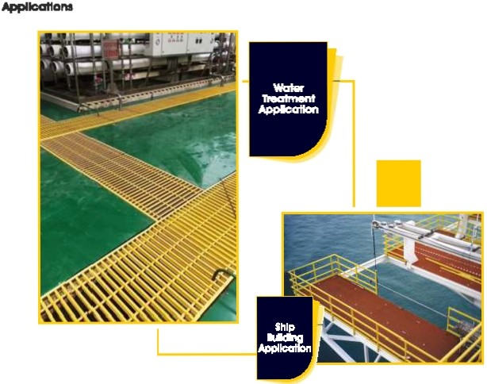
•

lndlai-5rote™
Appllcal1Dl"ll

""Clln,.... 1'11. Ull.
Snee 1986

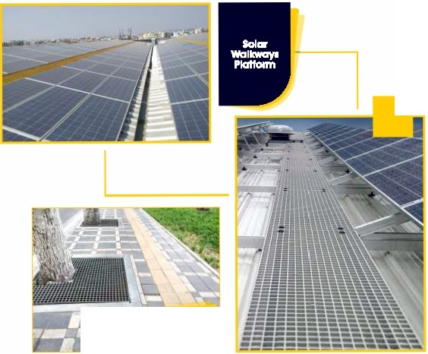
Trvv Guard
•

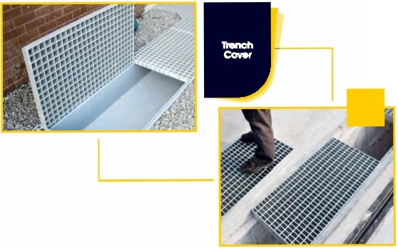
•

lndlofrote™

other Products

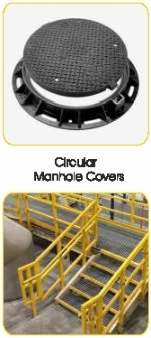
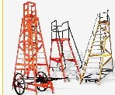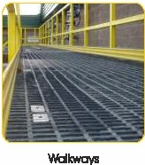Rel

Ughttng Poles

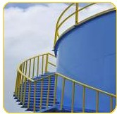Sfruclural Proflles

Hanc:tal

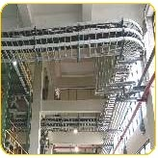cable Trays

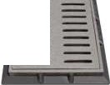-
-
-

SIPClnlpllllls M I.Ill.
Snce 1986






